**MAULANA AZAD NATIONAL INSTITUTE OF TECHNOLOGY BHOPAL**



**DEPARTMENT OF COMPUTER SCIENCE AND ENGINEERING**

**REPORT ON**

**Medical Image Enhancement using Histogram Equalization**

**Submitted by**

Budde Pavan Sai Varma 161112073

Vasishtha Kumar Nalla 161112090

Chintakindi Manideep Sai 161112069

(VII Semester, CSE)

**Under the guidance of**

Dr. Jyoti Bharti

Assistant Professor

Department of Computer Science and Engineering

MANIT Bhopal

**ABSTRACT**

Image Enhancement is one of the most important and complex techniques in image processing technology. The main aim of image enhancement is to improve the visual appearance of an image, or to offer a “better transform representation of the image. Various types of images like medical images, satellite images, aerial images and real life photographs suffer from different problems like poor contrast and noise. It is essential to enhance the contrast and remove the noise to increase image quality. Recently a lot of work has been done by different researchers and scientists in the field of image enhancement. Many techniques have already been proposed and devised for enhancing the digital images. Most of the techniques are based upon the concept of transform domain methods which can introduce artifacts which further reduce the intensity of the input image. The main objective of this project is to enhance the medical images by de-noising and improving the contrast of the image.

**INTRODUCTION**

Image enhancement process consists of a collection of techniques that are used to improve the visual appearance of an image. Image enhancement is a process by which the visual quality and the overall appearance of an image are improved so as to extract the spatial features of the image. The photographs taken using cellular phones and smartphones are generally of poor contrast. So, this type of images needs enhancement algorithms to improve its contrast. The main function of image enhancement is to improve the interpretability or perception of information contained in the image for human viewers. It creates output image that subjectively looks better than the original image by changing the pixel’s intensity of the input image.

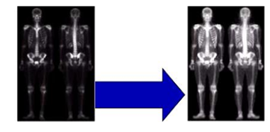

**Showing the effect of Image Enhancement**

Image enhancement, which is one of the important techniques in digital image processing, plays an important role in many fields, such as medical image processing, remote sensing, speech recognition, high definition television (HDTV), hyper spectral image processing, industrial X-ray image processing, microscopic imaging and many other image/video processing applications. Most of these techniques require interactive procedures to obtain suitable results, and therefore are not suitable for routine application.

Image enhancement is used to enhance the quality of images. The main applications of image enhancement are Aerial imaging, Satellite imaging, Medical imaging, Digital camera application and in remote sensing. Image Enhancement techniques used in many areas such as forensics, Astrophotography and in Fingerprint matching, etc. Color contrast enhancement, sharpening and brightening are some of the useful techniques used to make the images clear. Medical imaging uses this for reducing noise and sharpening details to improve the visual representation of the image. This makes image enhancement a necessary aiding tool for reviewing atomic region in MRI, ultrasound. Images that are obtained from fingerprint recognition, security videos analysis and crime scene investigations are enhanced to help in identification of culprits and protection of victims.

**METHODOLOGY**

**Image Enhancement:**

Image enhancement is a process that focuses on processing an image in such a way that the processed image is more suitable than the original one for the specific application. The word 'specific' has significance. It gives a clue that the results of such an operation are highly application dependent.

g(x, y) = T[f(x, y)]

Where f(x, y) is the input image, g(x, y) is the processed image and T is an operator on f defined over some neighborhood of (x, y).

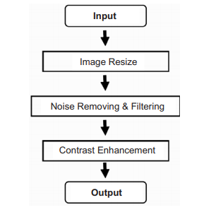

**Proposed Preprocessing Methodology**

**Histogram Equalization:**

The Histogram Equalization (HE) spreads out intensity values along the total range of values in order to achieve higher contrast. The goal of histogram equalization is to distribute the gray levels within an image so that every gray level is equally likely to occur. Histogram equalization will increase the brightness and contrast of dark and low contrast images.

Histogram equalization is used to enhance contrast. It is not necessary that contrast will always increase in this. There may be some cases were histogram equalization can be worse. In those cases the contrast is decreased.

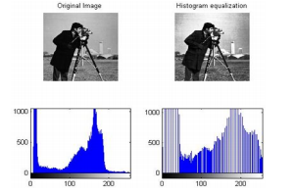

**An image and its histogram before and**

**after histogram equalization**

**Noise Removing:**

Image noise is generally observed as an undesirable by-product during image acquisition. Noise is often defined as the uncertainty in the signal due to random fluctuations in signals. Several types of noise exist and the most common noise found in the medical images are explained below:

**Salt-and-Pepper Noise:** Salt and pepper noise is noise that is most frequently seen in an image. It denotes as randomly occurring black and white pixels. Salt and pepper noise sneaks into image in conditions where rapid transients, such as defective swapping, take place. It is also called as impulsive noise or spike noise.

**Gaussian Noise:** Gaussian noise is statistical noise that has a probability density function (pdf) of the normal distribution, also known as Gaussian distribution. In Gaussian noise, each pixel in the image will be changed from its original value by a (usually) small amount.

**Shot or Poisson Noise:** Shot noise, otherwise known as poisson noise is the dominant noise in the lighter parts of an image from an image sensor is typically caused by statistical quantum fluctuations, that is, variation in the number of photons sensed at a given exposure level; this noise is known as photon shot noise.

**Speckle Noise:** Speckle noise is a granular noise that inherently exists in and degrades the quality of the active radar and synthetic aperture radar images. In this type of noise are usually seen in ultrasonic medical devices.

**Filtering:**

Filtering technique for modifying or enhancing an image, in image processing filters are mainly used to suppress either the high frequencies in the image, i.e. smoothing the image, or the low frequencies, i.e. enhancing or detecting edges in the image. For example, you can filter an image to emphasize certain features or remove other features.

**Median Filter:** The median filter run through each element of the signal (in this case the image) and replace each pixel with the **median** of its neighboring pixels (located in a square neighborhood around the evaluated pixel).

**Gaussian Filter**: Gaussian filtering is done by convolving each point in the input array with a Gaussian kernel and then summing them all to produce the output array.

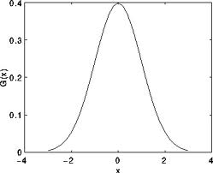

Assuming that an image is 1D, you can notice that the pixel located in the middle would have the biggest weight. The weight of its neighbors decreases as the spatial distance between them and the center pixel increases.

**Bilateral Filter**:

A bilateral filter is a non-linear, edge-preserving, and noise-reducing smoothing filter for images. It replaces the intensity of each pixel with a weighted average of intensity values from nearby pixels. This weight can be based on a Gaussian distribution.

**Power Law Transformation:**

This operator, also called gammacorrection, is another operator we can use to enhance an image.At the pixel (i,j), the operator looks as follows:

p(i,j) = I(i,j)^gamma

Where I(i,j) is the Intensity values at location(i,j).

**Morphological Opening Filter:**

Morphological opening is useful for removing small objects from an image while preserving the shape and size of larger objects in the image.

**Laplacian Filter:**

The Laplacian of an image highlights the areas of rapid changes in intensity and can thus be used for edge detection. If we let *I(x,y)* represent the intensities of an image then the Laplacian of the image is given by the following formula:



**REQUIREMENT TO RUN CODE(DEPENDENCY)**

**Software:**

We are using MINICONDA distribution 5.3 compiled with Python 3.7 using jupyter notebook in it. Python has vast collection of machine learning libraries.

**Hardware:**

Processor that we will use is Intel(R) Core (TM) i56100 CPU@2.30GHz and system type is 64-bit operating system, x64-based processor.

**Libraries:**

* OpenCV
* Matplotlib
* Numpy

**RESULT AND DISCUSSION**

**Histogram Equalization:**

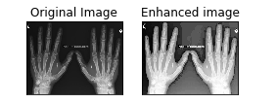

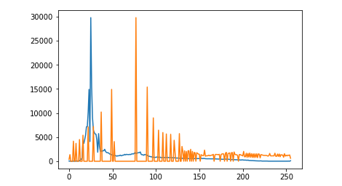

**Histogram of original image and enhanced image**

**Applying Median Blurred Filter:**

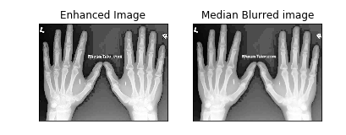

**Applying Guassian Filter:**

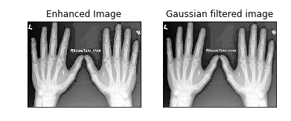

**Applying Bilateral Filter:**

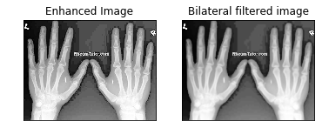

**Applying Power Law Transformation on the Image:**

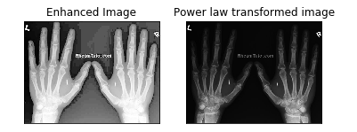

**Applying Morphological Opening Filter:**

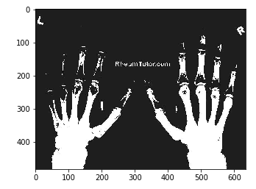

**Applying Laplacian Filter and appending it with the original Image:**

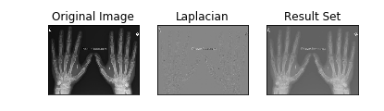

**CONCLUSION**

We discussed the medical image preprocessing techniques. In the image,noise is detected and also removed from the given mammogram images, in the image it can be applied with different filtering techniques namely Gaussian, Bilateral, Median filters etc. This work we have detected that the choice of filters for denoising the medical mammogram images depends vitally on the type of noise and type of filtering, which are selected and used. It is remarkable that techniques save the processing time. This result in analysis will improve the accuracy of mammogram image. The results, which we have achieved, are more useful and they prove to be helpful for medical practitioners to analyze the symptoms in the patients.

**BIBLIOGRAPHY**

[1].Sukhjinder Singh, R.K. Bansal and Savina Bansal, Medical Image Enhancement Using Histogram Processing Techniques Followed by Median Filter,2015

[2].Sargun and Shashi B. Rana, A Review of Medical Image Enhancement Techniques for Image Processing , 2015

[3].[Manvir Sekhon](https://towardsdatascience.com/@m4nv1r5?source=follow_footer--------------------------follow_footer-), [https://towardsdatascience.com/image-filters-in-p](https://towardsdatascience.com/image-filters-in-python-26ee938e57d2)ython

-26ee938e57d2

[4].<https://stackoverflow.com/questions/52004133/how-to-improve-image-quality>

[5].Abder Rehman Ali, [https://code.tutsplus.com/articles/image-enhancement-in](https://code.tutsplus.com/articles/image-enhancement-in-python--cms-29289)-

python--cms-29289